Geometry: Unit 7, Lesson 8

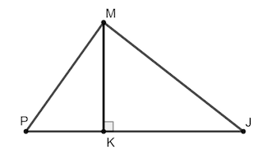
- Right triangles $PMK$ and $MJK$ are shown with a shared side, $\overline{MK}$, where $∠PKM$ and $∠MJK$ are right angles, $m∠MPK=54°$, and $m∠MJK=36°$. What expression can be used to find $m∠PMJ$?

$$180°-54°-36°$$

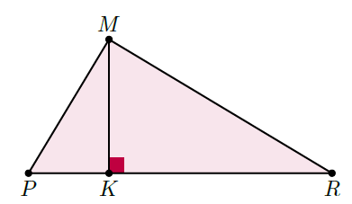
- Right triangles $PMK$ and $MRK$ are shown with a shared side, $\overline{MK}$, where $∠PKM$ and $∠MKR$ are right angles, $m∠MPK=59°$, $m∠MRK=31°$, $MR=7$, and $KR=6$. What is the length of $\overline{MK}$, in simplest radical form?

$$\sqrt{13}$$
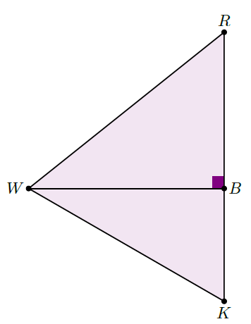
- Right triangles $RBW$ and $BKW$ are shown where $m∠RBW=90°$, $m∠KWB=30°$, $RW=4.1$, and $RB=3$. Which of the following side lengths must be found to determine the area of $∆BKW$?

$$\overline{BW}$$

